Jshell(Java Shell)

Java REPL Read Eval Print Loop

Type in one line of code( or multiple) and see output

Introduced in Java 9

Installation: Download JDK from Oracle and install

Set the Environment variable path in System variable.

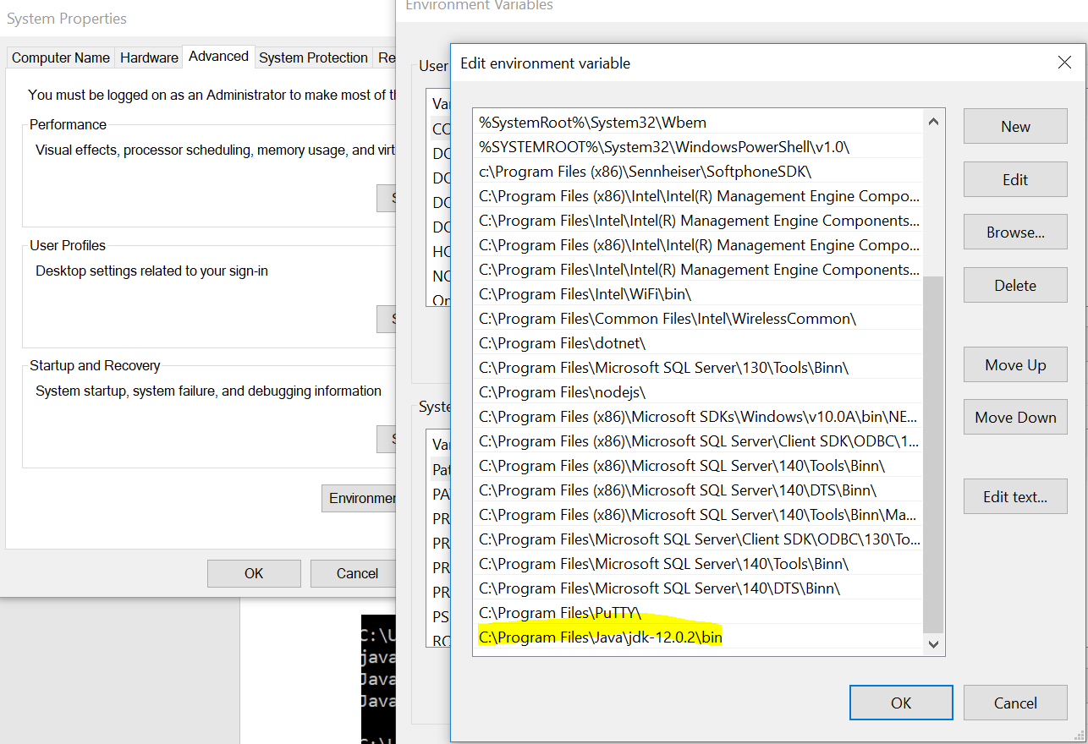

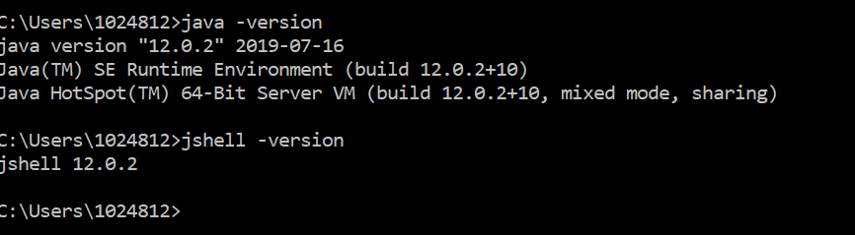

How to Launch Jshell: Open command Prompt and Enter jshell.

Note: Before launching jshell please check whether the java and jshell is installed succesfully or not using java -version and jshell -version

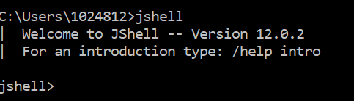

To command out of the shell: /exit

Write an Expression to calculate number of minutes in a day? - 1440

Write an expression to calculate number of seconds in a day? - 86400

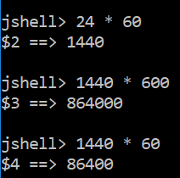

Four integer data types in Java:

Int

Byte

Short

Long

